**PLANNING PROPOSAL GOSFORD CITY COUNCIL**

This Planning Proposal has been drafted in accordance with Section 55 of the *Environmental Planning and Assessment Act, 1979* and the Department of Planning & Environment's *A Guide to Preparing Planning Proposals* and *Guide to Preparing Local Environmental Plans.*

A gateway determination under Section 56 of the Environmental Planning and Assessment Act is requested from the DP&E.

**Part 1 Objectives or Intended Outcomes**

***Section 55(2)(a) A statement of the objectives or intended outcomes of the proposed instrument.***

The objective/intended outcome of the Planning Proposal is to zone the land to allow an intensity of landuse which is commensurate with its physical characteristics and surrounding landuses. In this regard the cleared and relatively level areas are proposed to be permitted for industrial use. The rainforest area and associated riparian buffer are proposed to be protected with no development being permitted. The escarpment areas of the land will also be protected with only limited or no development being permitted reflective of the land also being identified as a potential COSS inclusion.

**Part 2 Explanation of Provisions**

***Section 55(2)(b) An explanation of the provisions that are to be included in the proposed instrument.***

The objectives/intended outcomes are to be achieved by amending the Gosford LEP.2014 and Interim Development Order 122 by;

(a)The zoning of a portion of the land IN1 – General Industrial and the zoning of the majority of the land E2 – Environmental Conservation and RE1 – Public Recreation (COSS land);

(b)The application of a minimum lot size of 40 ha for the E2 – Environmental Conservation zoned land; and

(c)The application of an 8.5 m height limit for the E2 – Environmental Conservation zoned land.

***Section 55(2)(d) If maps are to be adopted by the proposed instrument, such as maps for proposed land use zones, heritage areas, flood prone land – a version of the maps containing sufficient detail to indicate the substantive effect of the proposed instrument.***

Attachment B to this report contains all relevant mapping to the Planning Proposal.

**Part 3 Justification for objectives & outcomes**

***Section 55(2)(c) The justification for those objectives, outcomes and provisions and the process for their implementation (including whether the proposed instrument will comply with relevant directions under section 117).***

**Section A Need for the Planning Proposal**

1. **Is the Planning Proposal a result of any strategic study or report?**

The Planning Proposal is not the result of any strategic study or report. Land identified for inclusion in the COSS has been identified since the 1990s in Council strategic studies.

**2 Is the Planning Proposal the best means of achieving the objectives or intended outcomes, or is there a better way?**

The Planning Proposal is the best means of achieving the objectives/intended outcomes as it will establish the preferred landuses for the land and provide protection, through zoning, for environmentally and visually sensitive portions of the land.

**Section B Relationship to strategic planning framework**

**3 Is the Planning Proposal consistent with the objectives and actions contained within the applicable regional or sub-regional strategy (including the Sydney Metropolitan Strategy and exhibited draft strategies)?**

Regional strategies include outcomes and specific actions for a range of different matters relevant to the region. In all cases the strategies include specific housing and employment targets also. The Central Coast Regional Strategy 2006 – 2031 is applicable to the subject land and the proposed rezoning. The Planning Proposal will assist Council in meeting the targets set by the State Government in the Regional Strategy for provision of jobs. This Planning Proposal is consistent with the following objectives/actions contained within the Regional Strategy:

5.1 Promote economic and employment in the region to increase the level of employment self-containment and achieve capacity for more than 45,000 new jobs on Central Coast over the next 25 years.

6.4 LEPs are to appropriately zone land with high landscape value (including scenic and cultural landscapes).

6.5 Councils, through preparation of LEPs are to incorporate appropriate land use buffers around environmentally sensitive, rural and resource lands.

**3a** **Does the proposal have strategic merit and is it consistent with the Regional Strategy and Metropolitan Plan, or can it otherwise demonstrate strategic merit in light of Section 117 Directions?**

The Planning Proposal is considered to have strategic merit as it will provide employment lands as well as protect land of high scenic and environmental quality.

**3b Does the proposal have site-specific merit and is it compatible with the surrounding land uses, having regard to the following: the natural environment (including known significant environmental values, resources or hazards) and the existing uses, approved uses, and likely future uses of land in the vicinity of the proposal and the services and infrastructure that are or will be available to meet the demands arising from the proposal and any proposed financial arrangements for infrastructure provision.**

Subject to the appropriate zoning of the land to reflect its physical characteristics the Planning Proposal has site specific merit and will be consistent with the adjoining land uses. In this regard:

- The proposed industrial zoned land will be confined to cleared and relative level portions of the site that adjoin the local road network and are adjacent to existing industrially zoned land in the West Gosford Industrial area. The land forms one of the last opportunities to provide new industrial zoned land in the West Gosford locality.

- The proposed Conservation zoned portion that coincides with the rainforest and flood liable land is part of creek area that runs from the escarpment through the property linking with the creek that flows into Narara Creek. The proposed zoning will provide protection for these sensitive areas.

- The proposed Conservation zoned portion that coincides with the escarpment is part of a wider Conservation area that constitutes the western escarpment to the Gosford City Centre is part of the land that constitutes the ‘western COSS’.

The provision of sewerage infrastructure to the land is a matter that needs to be addressed as part of a Gateway Determination .This will be done by way of a system capacity analysis that would be required as part of a Gateway Determination.

**4 Is the Planning Proposal consistent with the local Council’s Community Strategic Plan, or other local strategic plan?**

The Planning Proposal is consistent with the Community Strategic Plan in the following areas;

B1.1 Identify and manage threats to native flora and fauna

B1. 2 Identify and conserve areas of conservation value

C1.1 Broaden range of business and industry sectors

C2.1 Provide tools and framework for business growth

Council’s Policy for the ‘Rezoning of Conservation 7(a) land’ applies to the Planning Proposal. The Policy Objectives of this policy are;

*1To define objectives for the Conservation 7(a) / E2 zone to ensure the long term preservation of the scenic and environmental qualities of the region and to*

*Preservation of the scenic and environmental qualities of the region and to ensure Planning Proposals (i.e. LEPs) are consistent with the prescribed objectives.*

*2 To establish criteria to be used by Council to assess requirements to prepare a*

*Planning Proposal.(i.e. local environmental plan) primarily for the purpose of providing dedication of strategically environmentally/scenically important land for the community benefit in exchange for additional development rights having regard to the land’s attributes pertaining to the zone boundary of the 7(a) conservation zone / Environmental Conservation E2, but also for the purpose to alter the zone, uses, subdivision or other provisions.*

The Planning Proposal is requesting the rezoning of Conservation zoned land that is in part identified for inclusion in the Coastal Open Space System. Council’s Rezoning of 7(a) land policy requires that in such circumstances the following will apply;

*- The Council will consider proposals which will result in substantial areas of land identified in the Coastal Open Space System being dedicated at no cost or minimal cost. Where generally consistent with the objectives of this Policy, it may be possible to identify suitable areas for single dwelling development*.

*- The strategic basis of the proposal is to be outlined, i.e. the relationship to the Coastal Open Space System of any proposed land dedication in exchange for additional development rights and the effects of such a proposal.*

The portion of the land above the escarpment is visually significant as viewed from the east. The land has been identified as part of COSS .This portion of the land adjoins an existing Council reserve dedicated as part of the subdivision for industrial purposes of the original land parcel. The applicant has not indicated whether the owner is prepared to enter into any agreements in relation to the dedication of this land as part of the Planning Proposal.

Council through the rezoning process is providing a significant improvement in the value of the least physically constrained portion of the land for the owner. A return for the community from this ‘betterment’ would be the dedication of the portion of the land identified for inclusion in the COSS.The recoupment of some of this betterment is the basis for those parts of the Policy that relate to the land dedication. It is proposed that this be further investigated as part of the next stage of the rezoning process. Further discussion is provided on this matter in the “Other Matters for Consideration” section of this report.

**5 Is the Planning Proposal consistent with applicable State Environmental Planning Policies?**

The following assessment is provided of the relationship of the planning proposal to relevant State Environmental Planning Policies.

**SEPPs applicable**

**SEPP19 - Urban Bushland**

1. Clause 10 of State Environmental Planning Policy No. 19 states:

*When preparing draft local environmental plans for any land to which this Policy applies, other than rural land, the council shall:*

*(a) have regard to the general and specific aims of the Policy, and*

*(b) give priority to retaining bushland, unless it is satisfied that significant environmental, economic or social benefits will arise which outweigh the value of the bushland.*

The aims and objectives of the SEPP are:

*(1) The general aim of this Policy is to protect and preserve bushland within the urban areas referred to in Schedule 1 because of:*

*(a) its value to the community as part of the natural heritage,*

*(b) its aesthetic value, and*

*(c) its value as a recreational, educational and scientific resource.*

*(2) The specific aims of this policy are:*

*(a) to protect the remnants of plant communities which were once characteristic of land now within an urban area,*

*(b) to retain bushland in parcels of a size and configuration which will enable the existing plant and animal communities to survive in the long term,*

*(c) to protect rare and endangered flora and fauna species,*

*(d) to protect habitats for native flora and fauna,*

*(e) to protect wildlife corridors and vegetation links with other nearby bushland,*

*(f) to protect bushland as a natural stabiliser of the soil surface,*

*(g) to protect bushland for its scenic values, and to retain the unique visual identity of the landscape,*

*(h) to protect significant geological features,*

*(i) to protect existing landforms, such as natural drainage lines, watercourses and foreshores,*

*(j) to protect archaeological relics,*

*(k) to protect the recreational potential of bushland,*

*(l) to protect the educational potential of bushland,*

*(m) to maintain bushland in locations which are readily accessible to the community, and*

*(n) to promote the management of bushland in a manner which protects and enhances the quality of the bushland and facilitates public enjoyment of the bushland compatible with its conservation.*

An EEC (rainforest) has been identified as being located on the land. Subject to the component of the Planning Proposal relating to the industrial zoning being applicable to only the portion of the land that is not affected by the EEC and associated riparian buffer the Planning Proposal is considered to be consistent with this SEPP.

**SEPP – 55 Remediation of Land**

SEPP 55 applies to the land and provides the following in relation to Planning Proposals

*6   Contamination and remediation to be considered in zoning or rezoning proposal*

*(1)  In preparing an environmental planning instrument, a planning authority is not to include in a particular zone (within the meaning of the instrument) any land specified in subclause (4) if the inclusion of the land in that zone would permit a change of use of the land, unless:*

*(a)  the planning authority has considered whether the land is contaminated, and*

*(b)  if the land is contaminated, the planning authority is satisfied that the land is suitable in its contaminated state (or will be suitable, after remediation) for all the purposes for which land in the zone concerned is permitted to be used, and*

*(c)  if the land requires remediation to be made suitable for any purpose for which land in that zone is permitted to be used, the planning authority is satisfied that the land will be so remediated before the land is used for that purpose*.

The land has been consented to for remediation under DA45990/2014 for industrial purposes. Therefore, the requirements of SEPP 55 will have been addressed satisfactorily with the taking of action under this consent. This consent, and/or appropriate remediation would be required to be completed prior to any approval for new users of the land.

**6 Is the Planning Proposal consistent with applicable Ministerial Directions (Section 117 directions)?**

The following assessment is provided of the consistency of the Planning Proposal with relevant Section 117 Directions applying to Planning Proposals lodged after 1 September 2009. Section 117 Directions are only discussed where applicable. The Planning Proposal is consistent, with all other Section 117s Directions or they are not applicable.

***1.1 Business and Industrial Zones***

***Objectives***

*(1) The objectives of this direction are to:*

*(a) encourage employment growth in suitable locations,*

*(b) protect employment land in business and industrial zones, and*

*(c) support the viability of identified strategic centres.*

***Where this direction applies***

*(2) This direction applies to all relevant planning authorities.*

***When this direction applies***

*(3) This direction applies when a relevant planning authority prepares a planning proposal that will affect land within an existing or proposed business or industrial zone (including the alteration of any existing business or industrial zone boundary).*

***What a relevant planning authority must do if this direction applies***

*(4) A planning proposal must:*

*(a) give effect to the objectives of this direction,*

*(b) retain the areas and locations of existing business and industrial zones,*

*(c) not reduce the total potential floor space area for employment uses and related public services in business zones,*

*(d) not reduce the total potential floor space area for industrial uses in industrial zones, and*

*(e) ensure that proposed new employment areas are in accordance with a strategy that is approved by the Director-General of the Department of Planning*.

As the Planning Proposal involves the proposed zoning of the land to industrial purposes the Direction applies. The Planning Proposal is in accordance with this Direction as it complies with the objectives of the Direction which encourage employment growth in suitable locations, protect employment land in business and industrial zones, and support the viability of identified strategic centres.

**2.1 Environmental Protection Zones**

*Objective:*

*The objective of this direction is to protect and conserve environmentally sensitive areas.*

The land has located in its northern – eastern section an Endangered Ecological Community consisting of a rainforest. Subject to the location of the Conservation zone boundary to cover the land containing the EEC and associated riparian buffer, the Planning Proposal is consistent with this Direction.

***1. 4.3 Flood Prone Land***

***1. Objectives***

*The objectives of this direction are:*

1. *to ensure that development of flood prone land is consistent with the NSW Government’s Flood Prone Land Policy and the principles of the Floodplain Development Manual 2005, and*

*(b) to ensure that the provisions of an LEP on flood prone land is commensurate with flood hazard and includes consideration of the potential flood impacts both on and off the subject land.*

***1. When this direction applied***

*This direction applies when a relevant planning authority prepares a planning proposal that creates, removes or alters a zone or a provision that affects flood prone land.*

***1. What a relevant planning authority must do if this direction applies***

*A planning proposal must include provisions that give effect to and are consistent with the NSW Flood Prone Land Policy and the principles of the Floodplain Development Manual 2005 (including the Guideline on Development Controls on Low Flood Risk Areas).*

*A planning proposal must not rezone land within the flood planning areas from Special Use, Special Purpose, Recreation, Rural or Environmental Protection Zones to a Residential, Business, Industrial, Special Use or Special Purpose Zone.*

*A planning proposal must not contain provisions that apply to the flood planning areas which:*

1. *permit development in floodway areas,*
2. *permit development that will result in significant flood impacts to other properties,*
3. *permit a significant increase in the development of that land,*
4. *are likely to result in a substantially increased requirement for government spending on flood mitigation measures, infrastructure or services, or*
5. *permit development to be carried out without development consent except for the purposes of agriculture (not including dams, drainage canals, levees, buildings or structures in floodways or high hazard areas), roads or exempt development.*

*A planning proposal must not impose flood related development controls above the residential flood planning level for residential development on land, unless a relevant planning authority provides adequate justification for those controls to the satisfaction of the Director-General (or an officer of the Department nominated by the Director-General).*

*For the purposes of a planning proposal, a relevant planning authority must not determine a flood planning level that is inconsistent with the Floodplain Development Manual 2005 (including the Guideline on Development Controls on Low Flood Risk Areas) unless a relevant planning authority provides adequate justification for the proposed departure from that Manual to the satisfaction of the Director-General (or an officer of the Department nominated by the Director-General).*

Part of the north eastern corner of the lot is affected by the floodplain of an unnamed tributary of Narara Creek. The extent of the floodplain is defined in the Review of Narara Creek Flood Study - October 2013. The boundary of the proposed rezoning should be outside of the Flood Planning Area of this creek (i.e. 1% AEP + 0.5m freeboard + sea level rise allowance) and a land survey is recommended to be undertaken to confirm that it is.

The Review of Narara Creek Floodplain Risk Management Plan (RNCFRMP) is currently being undertaken for this area by consultants for Council. This study has identified properties within the existing downstream industrial area which are subject to extensive flooding, even in only minor flood events. This is attributed mainly to the existing industrial land being located on relatively flat topography below the upper steep vegetated areas of the catchment where flows can quickly run over ground and then spread when reaching the flatter downstream areas.

Any large development upstream in the steeper section of catchment therefore has the potential to significantly increase run off to the lower catchment, hence careful consideration should be undertaken for any proposed development so as not to make the flooding worse. This condition is reinforced in the current Lower Narara Creek Floodplain Management Plan - 1991 where it requires a detailed flood study to determine the potential flood impacts that would be created by any large development. Whilst Council’s consultant is undertaking a review of the flood affected areas of Narara Creek under the RNCFRMP it is an opportune time to use the consultants flood model and assess in detail any impacts that would be created by an increase in development intensity and assess and recommend management options to overcome any identified impacts.

Due to the existing flooding problems to properties downstream of this proposed rezoning it is recommended that the developer will need to commission Council’s consultant to assess their proposal for flooding impacts and solutions. All development would also be required to comply with Council’s DCP with regard to water cycle management and flooding impacts.

Any increase in runoff created by the proposed rezoning to allow more impermeable areas of land will generate increased runoff and if not properly controlled could worsen the existing flooding problems downstream and thus require an increase in government spending on flood mitigation measures for both capital and recurrent.

The provision of this information could take place as part of the requirements of a Gateway Determination.

**4.4 Planning for Bushfire Protection**

**Objectives**

*The objectives of this direction are:*

* 1. *to protect life, property and the environment from bush fire hazards, by discouraging the establishment of incompatible land uses in bush fire prone areas, and*
  2. *to encourage sound management of bush fire prone areas.*

**5. Where this direction applies**

*This direction applies to all local government areas in which the responsible Council is required to prepare a bush fire prone land map under section 146 of the Environmental Planning and Assessment Act 1979 (the EP&A Act), or, until such a map has been certified by the Commissioner of the NSW Rural Fire Service, a map referred to in Schedule 6 of that Act.*

**6. When this direction applies**

*This direction applies when a relevant planning authority prepares a planning proposal that will affect, or is in proximity to land mapped as bushfire prone land.*

**7. What a relevant planning authority must do if this direction applies**

*In the preparation of a planning proposal the relevant planning authority must consult with the Commissioner of the NSW Rural Fire Service following receipt of a gateway determination under section 56 of the Act, and prior to undertaking community consultation in satisfaction of section 57 of the Act, and take into account any comments so made.*

*As the land is subject to bushfire hazard the Planning Proposal will be referred to RFS as part of any Gateway Determination that maybe forthcoming if Council chooses to support continued preparation of the Planning Proposal.*

**(i)** **Direction 5.1 Implementation of Regional Strategies:** Clause (4) of the Direction requires Planning Proposals to be consistent with a Regional Strategy released by the Minister for Planning.

The Planning Proposal is considered to be consistent with the objectives and actions contained in the Central Coast Regional Strategy 2006 – 2031 as indicated in the response to Section B 3 above.

**(ii) Direction 6.1 – Approval and Referral Requirements:** Clause (4) of the Direction requires a Planning Proposal to minimise the inclusion of concurrence/consultation provisions and not identify development as designated development.

This Planning Proposal is consistent with this direction as no such inclusions, or designation is proposed.

**(iii) Direction 6.3 – Site Specific Provisions:** The Planning Proposal is consistent with this Direction as the Planning Proposal involves the zoning of the land.

**Section C Environmental, social and economic impact**

**7 Is there any likelihood that critical habitat or threatened species, populations or ecological communities, or their habitats, will be adversely affected as a result of the proposal?**

As indicated previously the land has located upon it an EEC. The means by which the EEC can be protected are contained within this report.

**8 Are there any other likely environmental effects as a result of the Planning Proposal and how are they proposed to be managed?**

The Planning Proposal has a number of environmental issues that will need to be addressed prior to it being able move beyond a Gateway Determination. These issues include the delineation of the EEC (E2 zone boundary), the extent of flooding

Such information should be requested to be provided as part of the additional information requirements associated with a Gateway Determination. This information will determine what management measures can be initiated on the site to protect both the development and the sensitive environment that is part of and surrounds the land.

Council’s Rainforest Policy in part provides;

*-.A minimum of a 50 metre development exclusion zone (ie. fringe buffer zone) surrounding any rainforest area.*

*.-A prohibition on any industrial development and/or extractive industry operations within rainforest catchments.*

In consenting to the rehabilitation of the land in DA 45990/2014 an approx.40 m buffer area to the rainforest is proposed. The interface between the buffer area and the rehabilitated cleared portion of the land created for the DA is considered to be appropriate as the zone boundary on the northern side of the land. Although less than the provision of the rainforest policy the 40m development exclusion zone is appropriate to the site given the previous approval for rehabilitation of the land.

The proposed zoning of the land for industrial purposes adjacent to the rainforest is contrary to Council’s rainforest policy. The concern in relation to locating industrial land adjacent to a rainforest is the impact of runoff from industrial uses on the quality of the rainforest. The buffer area will provide filtering for runoff from industrial uses. Provision can be made in conditions of consent for a development on the land that runoff be directed to Nells Road rather than to the creek that the rainforest fringes.

**9 How has the Planning Proposal adequately addressed any social and economic effects?**

There are not expected to be any social impacts from the Planning Proposal.

Economic impacts are expected to be positive as there will be additional financial investment and employment opportunities associated with the provision of further industrial zoned land in the West Gosford locality.

**Section D State and Commonwealth interests**

**10 Is there adequate public infrastructure for the Planning Proposal?**

**Water/Sewer**

Connection to Councils water and sewer reticulation systems is required and the following conditions shall apply:

* Connection of the proposed rezoned land to Councils existing water and sewer reticulation systems shall be subject to the existing system having sufficient capacity to accommodate future development on the land. The applicant shall be responsible for undertaking a water and sewer systems capacity analysis on Council’s reticulation systems. The analysis shall extend to a point within the water and sewerage reticulation systems where proposed demands / loadings from the rezoned area represent 5% or less of total capacity of each system. The analysis shall assess the impact the proposed rezoning / future development has on these systems. The capacity analysis shall be carried out in accordance with the WSAA method for determining system capacity and shall be based upon full development of the area currently serviced by the existing water and sewer systems utilising current land zonings without the rezoned area, and a second analysis with the inclusion of additional loads created by the proposed rezoning and subsequent development.
* The developer shall be responsible for the full cost of design and augmentation of Councils existing water and sewer infrastructure identified through the systems analysis as a result of the extra loadings from the proposed rezoning.

* The applicant shall be responsible for the design and construction of water supply and sewerage works required to connect the proposed rezoned land to Councils existing water supply and sewerage systems. The water and sewer designs must be submitted to Council for approval and shall be in accordance with Council’s water and sewer design standards.
* The applicant shall be responsible for obtaining written consent from the owners of any properties required to be entered upon to construct proposed sewer mains. A copy of relevant consents shall be provided to Council in conjunction with submission of design plans.
* The applicant shall be responsible for the design and construction of water supply and sewerage infrastructure within the rezoned area. The water and sewer designs must be submitted to Council for approval and shall be in accordance with Council’s water and sewer design standards.
* Payment of the current water and sewer headworks / augmentation contributions, in accordance with Council’s Services Charges policy.

**Roads**

Nells Road provides the primary access to the land. This road is not fully formed across the frontage of the land. It will be a condition of consent for a development application on the land that the road is completed.

**11 What are the views of State and Commonwealth Public Authorities consulted in accordance with the gateway determination, and have they resulted in any variations to the Planning Proposal?**

No consultations have yet been undertaken with State and Commonwealth agencies as the gateway determination has not yet been issued.

**Part 4 Mapping**

***S55(2)(d) If maps are to be adopted by the proposed instrument, such as maps for proposed land use zones, heritage areas, flood prone land - a version of the maps containing sufficient detail to indicate the substantive effect of the proposed instrument.***

Attachment B to this report contains all relevant mapping to the Planning Proposal.

**Part 5 Community Consultation**

***Section 55(2)(e) Details of the community consultation that is to be undertaken before consideration is given to the making of the proposed instrument.***

Subject to Gateway support community consultation will involve an exhibition period of 28 days. The community will be notified of the commencement of the exhibition period via a notice in the local newspaper and on the web-site of Gosford City Council. A letter will also be sent to the adjoining landowners

The written notice will:

- give a brief description of the objectives or intended outcomes of the planning proposal,

- indicate the land affected by the planning proposal,

- state where and when the planning proposal can be inspected,

- give the name and address of Gosford City Council for receipt of submissions, and

- indicate the last date for submissions.

During the exhibition period, the following material will be made available for inspection:

- the planning proposal, in the form approved for community consultation by the Director-General of Planning,

- the gateway determination, and

- any studies relied upon by the planning proposal.

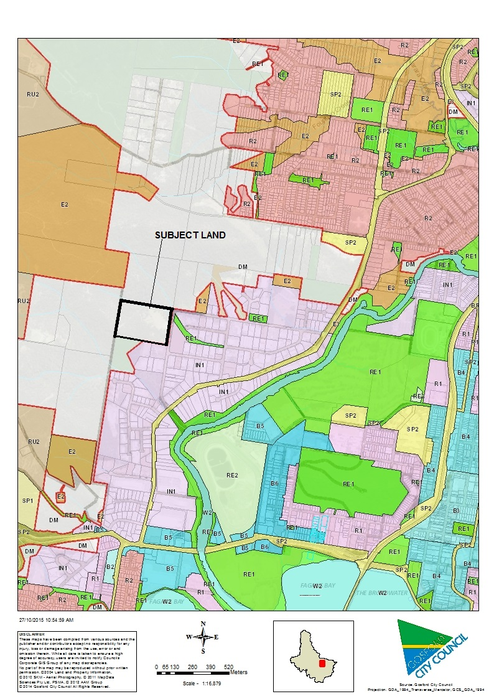

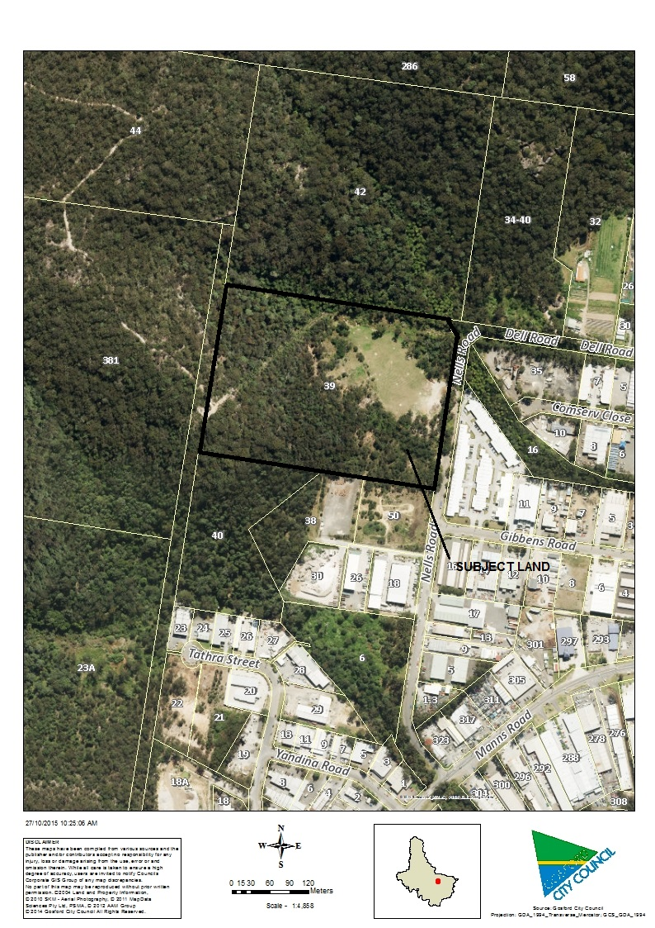

EXISTING ZONING

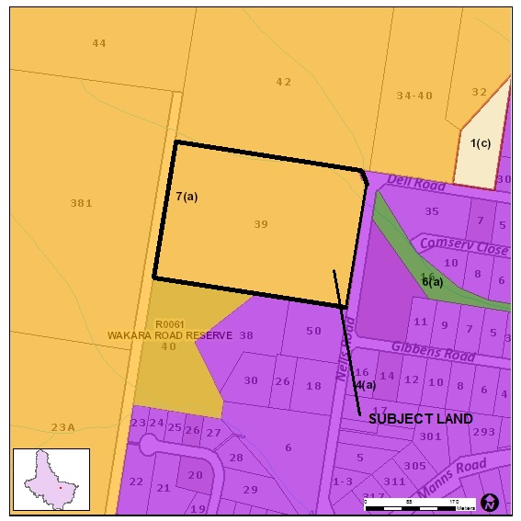

PROPOSED ZONING

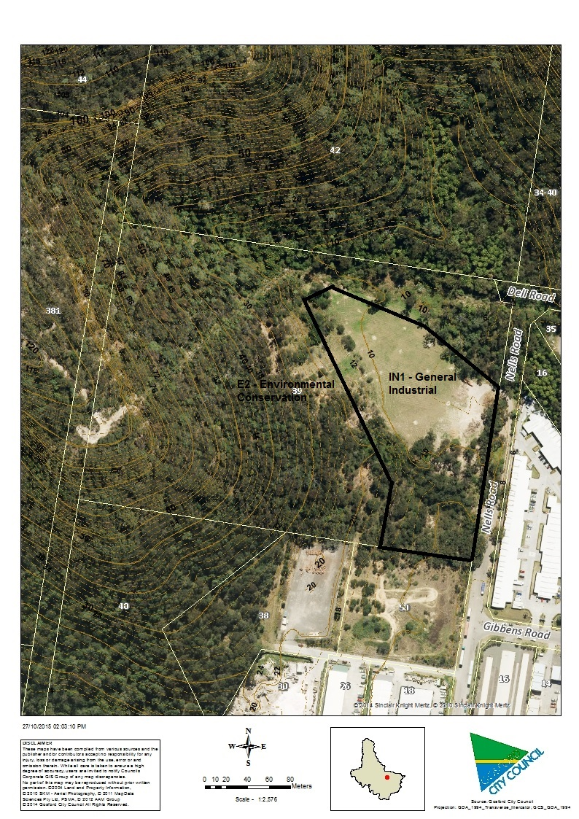

**Zoning – Miscellaneous Amendments LEP (in red)**



FLOODING

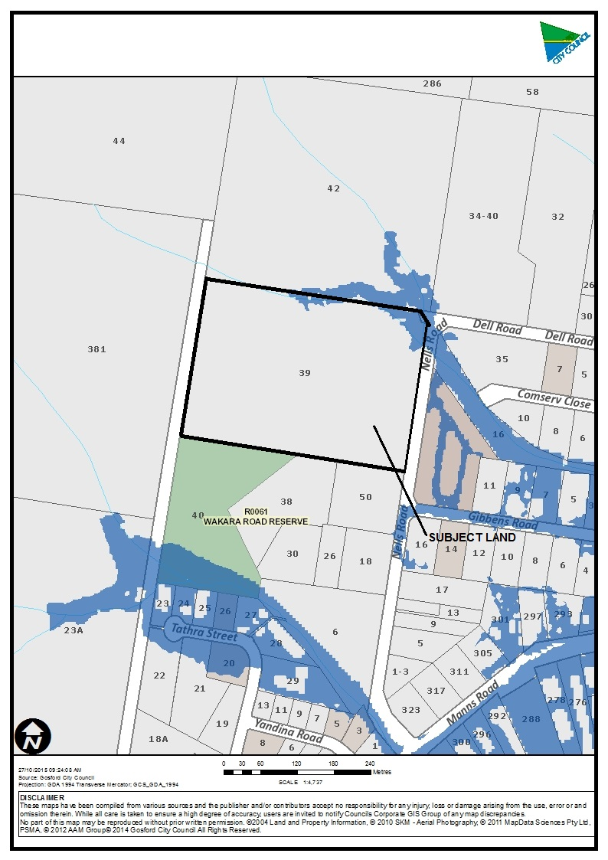

BUSHFIRE HAZARD

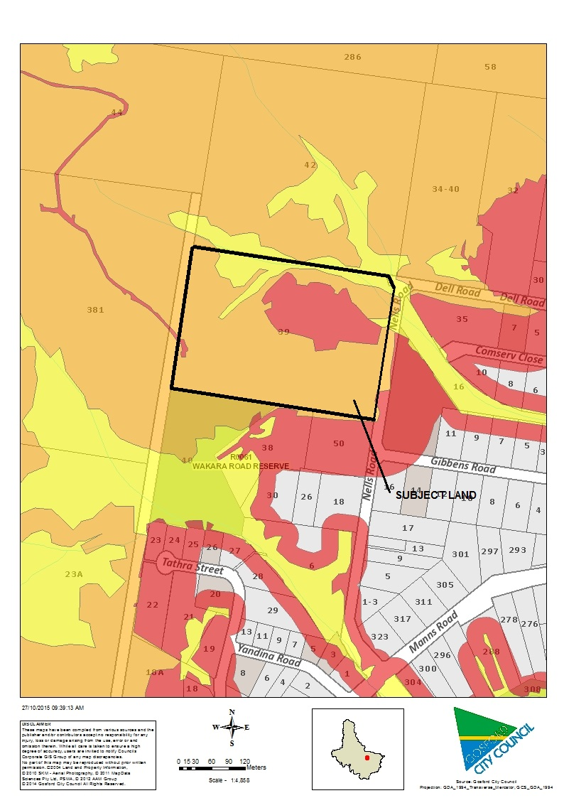

COSS ACQUISITION

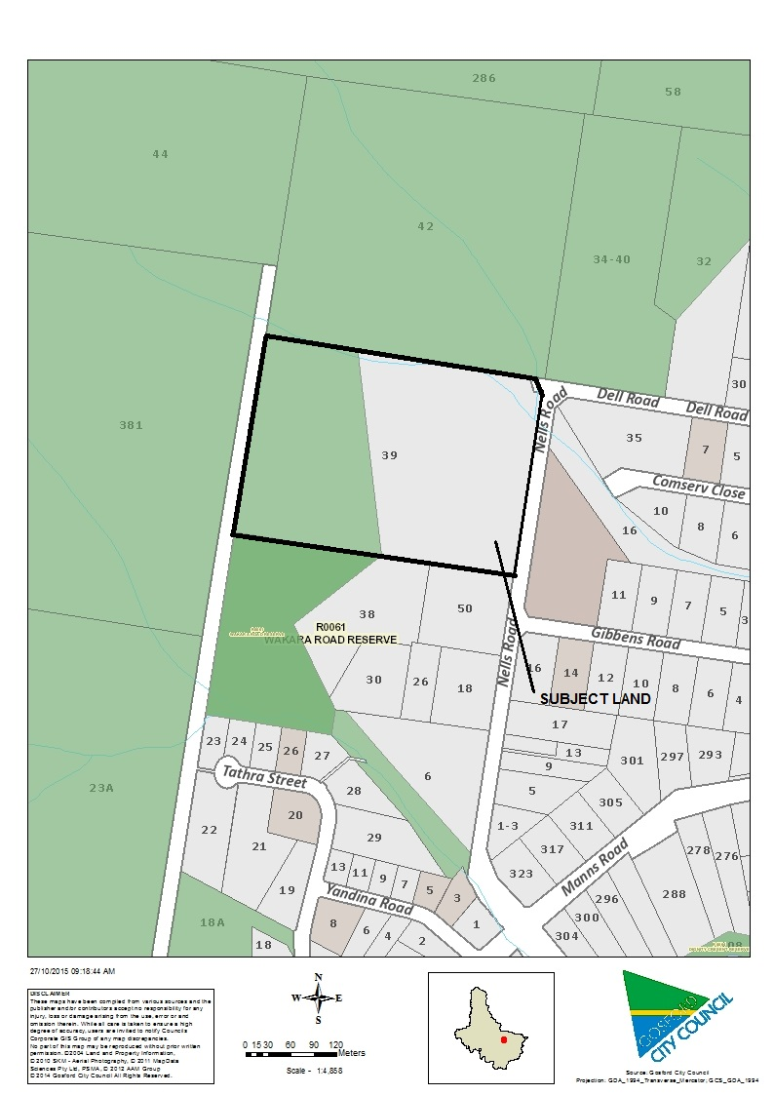

EEC (in red)

